FIELD REPORT
Introduction
Place: Barlonyo HC III
Location: Barlonyo
Date of visit: 31st August 2026
- General observations
- The verification exercise was successfully conducted with the facility in charge and all UgIFT-provided assets were physically verified against the available stock cards and delivery notes. The facility has designated a staff member to oversee and manage UgIFT-provided assets, supporting proper accountability and tracking.
- The assets were well-labelled and properly organized within the store, making them relatively easy to identify and track.
- The facility demonstrated good accountability practices, with relevant documentation and an identified person responsible for the management of UgIFT assets. However, there items seen on ground but not seen on the delivery notes but reported as UGIFT.

Special notes
- Some laboratory equipment, including the microscope and centrifuge, was found to be non-functional. This limits the facility's ability to fully utilize the equipment provided under UgIFT and may affect the delivery of laboratory services thus requring assessed by qualified technicians and repaired where possible. Where repair is not feasible, replacement should be considered to restore functionality.
- The facility does not have an adequate or standard laboratory room to appropriately accommodate and protect sensitive laboratory equipment. The lack of suitable laboratory infrastructure may expose equipment to damage and limits the facility's ability to provide effective laboratory services.
- Poor road access to the facility presents a challenge to routine maintenance and servicing of equipment, particularly where technical personnel need to travel to the facility.
- The facility demonstrates good accountability and asset management, particularly through the use of stock cards, delivery documentation, asset labelling, and designation of a responsible staff member.
- Some of the names of the items given under the UgiFT programme were not known.

OUTPATIENT DEPARTMENT BUILDING | 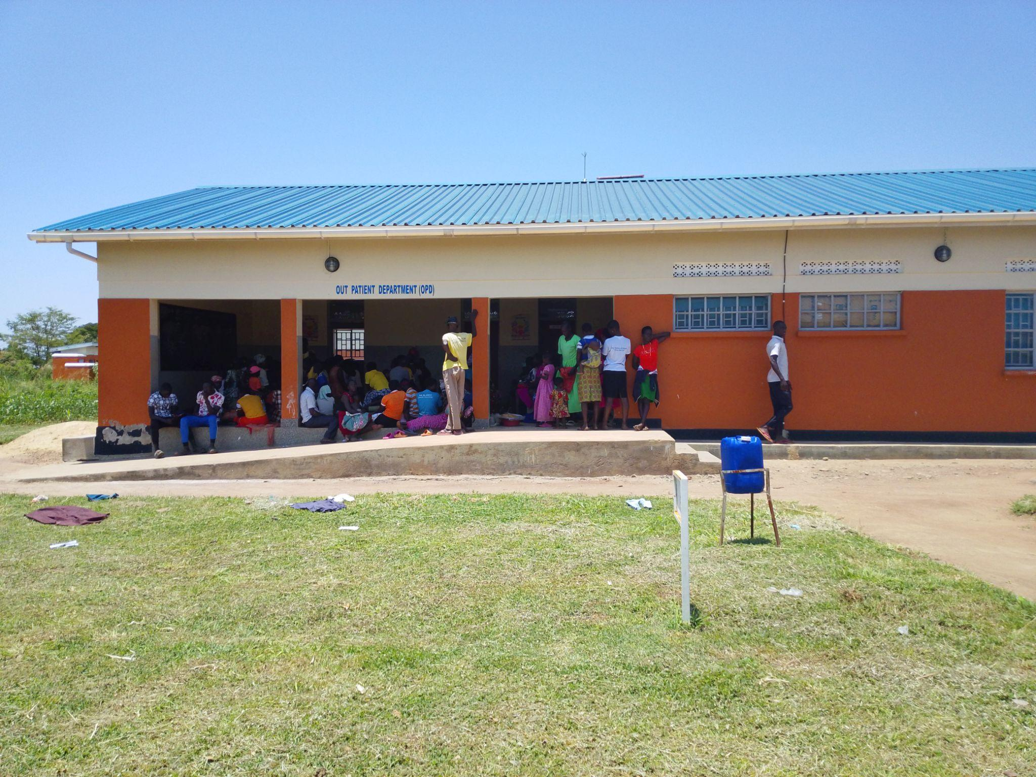
MATERNITY BLOCK | 